A1141-Afr-Egy-Amulet-Bastet-Late Period, 525-334 BCE**-Steatite**

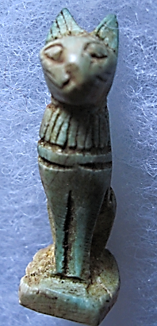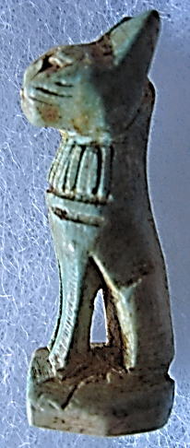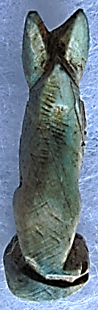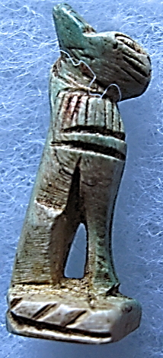

Figs. 1-4. Amulet-Bastet-Late Period, 525-334 BCE**-Steatite**

**Formal Label:** Amulet-Bastet-Late period, 525-334 BCE**-Steatite-With Pendant Loop**

**Display Description:** Bastet was a local feline deity whose religious sect was centered in the city o*Per-Bast* (Egyptian, “*House of Bast”*), Bubastis (Greek, *Βούβαστις*), in the Nile Delta. This carved green steatite sculpture is a sensitive interpretation of the cat goddess that had evolved from her lioness forebear.

**Accession Number: 1142**

**LC Classification:** DT62

**Date or Time Horizon:** 525-334 BCE

**Geographical Area:** Bubastis

**Map, GPS Coordinates:** [30°34′N 31°30′E](https://tools.wmflabs.org/geohack/geohack.php?pagename=Zagazig&params=30_34_N_31_30_E_region:EG_type:city%28319707%29)

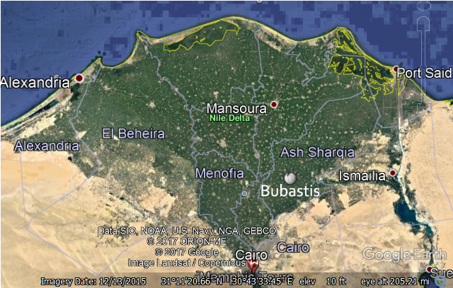

Fig. 5. Map od Lower Egypt showing relative location of Bubastis.

**Cultural Affiliation:** Late Period

**Medium:** Steatite

**Dimensions: 43.69 mm, 1.72 in.  
Weight: 10 gm, .25 oz.**

**Provenance: Old European Collection**

**Condition: Original**

**Discussion:** Bastet was worshiped beginning in the 2nd Dynasty (2890 BCE) as Bast, the goddess of warfare in Lower Egypt, before the unification under Narmer. Sekhmet was the parallel warrior lioness deity in Upper Egypt. Almost 2,000 years passed, when, during the 22nd Dynasty (c. 945–715 BC), Bast evolved from a lioness warrior deity into a major protector deity represented as a cat (Bakr and Brandl 2010: 27-36). The dynamics of this evolution suggests that personal religion was beginning to usurp the religion of the individual nomes of the “state”. Herodotus, a Greek historian who traveled in Egypt in the 5th century BCE, describes Bastet's temple at some length (History, Book 2, chapter 138):

Save for the entrance, it stands on an island; two separate channels approach it from the Nile, and after coming up to the entry of the temple, they run round it on opposite sides; each of them a hundred feet wide, and overshadowed by trees. The temple is in the midst of the city, the whole circuit of which commands a view down into it; for the city's level has been raised, but that of the temple has been left as it was from the first, so that it can be seen into from without. A stone wall, carven with figures, runs round it; within is a grove of very tall trees growing round a great shrine, wherein is the image of the goddess; the temple is a square, each side measuring a furlong. A road, paved with stone, of about three furlongs' length leads to the entrance, running eastward through the market place, towards the temple of Hermes; this road is about 400 feet wide, and bordered by trees reaching to heaven.

**References:**

Bakr, Mohamed I. and H. Brandl. 2010. "Bubastis and the Temple of Bastet". In M. I. Bakr; H. Brandl & F. Kalloniatis. Egyptian Antiquities from Kufur Nigm and Bubastis. Cairo/Berlin: Museen im Nildelta.